
NAME: MUDASSAR AHMAD

ROLL: SU92-BSDSM-S25-005

SUBJECT:AI(LAB)

SUBMITTED TO: SIR RASIKH ALI

Table of Contents
OBJECTIVE 4
INTRODUCTION 4
ALGORITHM STEPS 4
Code 4
OUTPUT 5
CONCLUSION 5
APPLICATIONS 6
ADVANTAGES 6
LIMITATIONS 6

AI LAB TASK # 8

OBJECTIVE
To understand and implement the Minimax Algorithm which is used in Artificial Intelligence for decision making in gaming.

INTRODUCTION
Minimax algorithm is a decision-making algorithm which is used in Artificial Intelligence. It is specially in two player games such as the chess, tic-tac-toe and number guessing etc. It works on the principle that one of the players tries to maximize the score and the other player tries to minimize the score.
This algorithm explores all possible moves in a game tree using the recursion method. At each level, it will alternate between maximizing and minimizing players. The maximizer selects the move with the highest value, and the minimizer selects the move with lowest value.
It assumes that both the players play optimally and helps in finding the best possible outcome from the given game state.

ALGORITHM STEPS
- Start from the root node.
- Traverse the tree until leaf nodes are reached
- If it is the maximizing player turn, it chooses the maximum value
- If it is the minimizing player's turn, it chooses the minimum value
- Repeat the process recursively
- Return the optimal value to the root node

Code
#MINMAX ALGORITHM USED IN GAMING
import math
def minmax(depth,index,maxi,score,target):
if depth==target:
return score[index]
if maxi:
return max(
minmax(depth+1,index*2,False,score,target)
,minmax(depth+1,index*2+1,False,score,target)
)
else:
return min(
(minmax(depth+1,index*2,True,score,target))
,minmax(depth+1,index*2+1,True,score,target)
)
#COdE FOR TESTING FUNCTION
score=[3,6,9,15,18,11,2,5]
tree=int(math.log2(len(score)))
print("The optimal value is:",minmax(0,0,True,score,tree))

OUTPUT
The optimal value is : 6

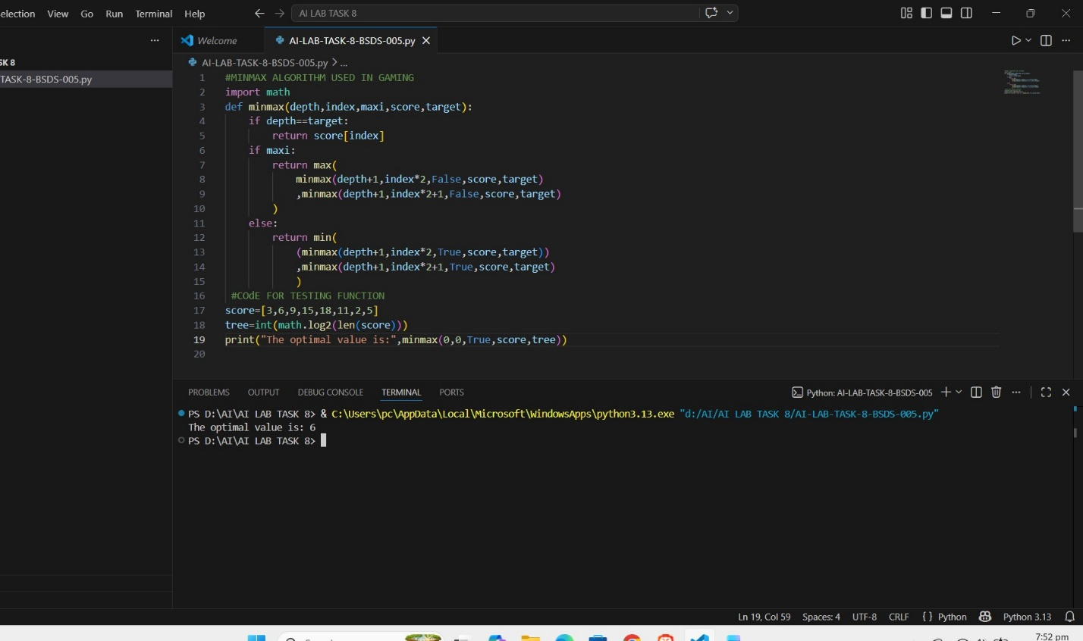

CONCLUSION
The Minimax algorithm successfully implemented. It helps us in selecting the best possible move in the game by considering all the possible outcomes. This algorithm is mainly used in the Artificial Intelligence for decision making in the competitive environments.

APPLICATIONS
- It is Used in games like Chess, Tic-Tac-Toe.
- It is used in Decision making in AI systems .
- It is used to solve Game theory problems.

ADVANTAGES
- It Guarantees the best optimal solution.
- It is very Simple and easy to understand.

LIMITATIONS
- It is very Slow for the large game trees.
- It can sometimes Requires more memory.

